**MESD LMS Documentation – View all students enrolled into a teacher’s class or subject**

**Purpose**

To be able to view all students enrolled into a teacher’s class or subject.

**Background**

This module handles requests directly from Educators within the Moodle system, allowing functionality to view all students enrolled into that Educator’s class or subject.

**Usage**

**View students enrolled into a class or course/subject**

1. Login as an Educator.
2. Go to ‘*Site Administration*’ > ‘*Courses*’ tab. Under the Courses category click on ‘*Manage courses and categories*’.
3. Click on the courses category.

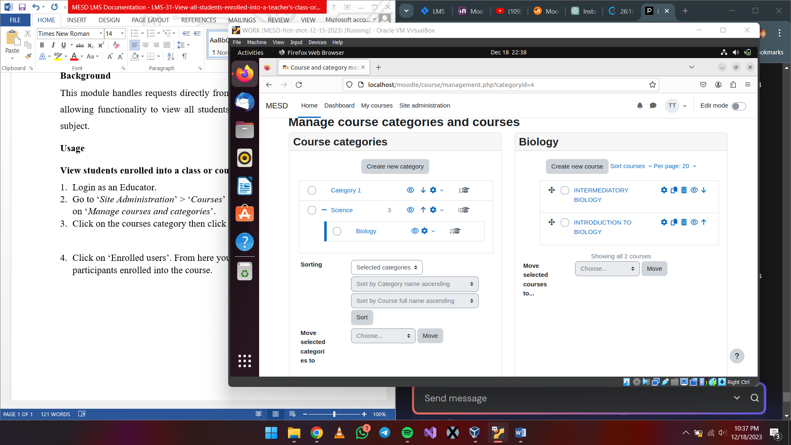

1. Click the course in the screen on the right.



1. Click on *‘Enrolled users’*. From here you can view all the students and other participants enrolled into the course.

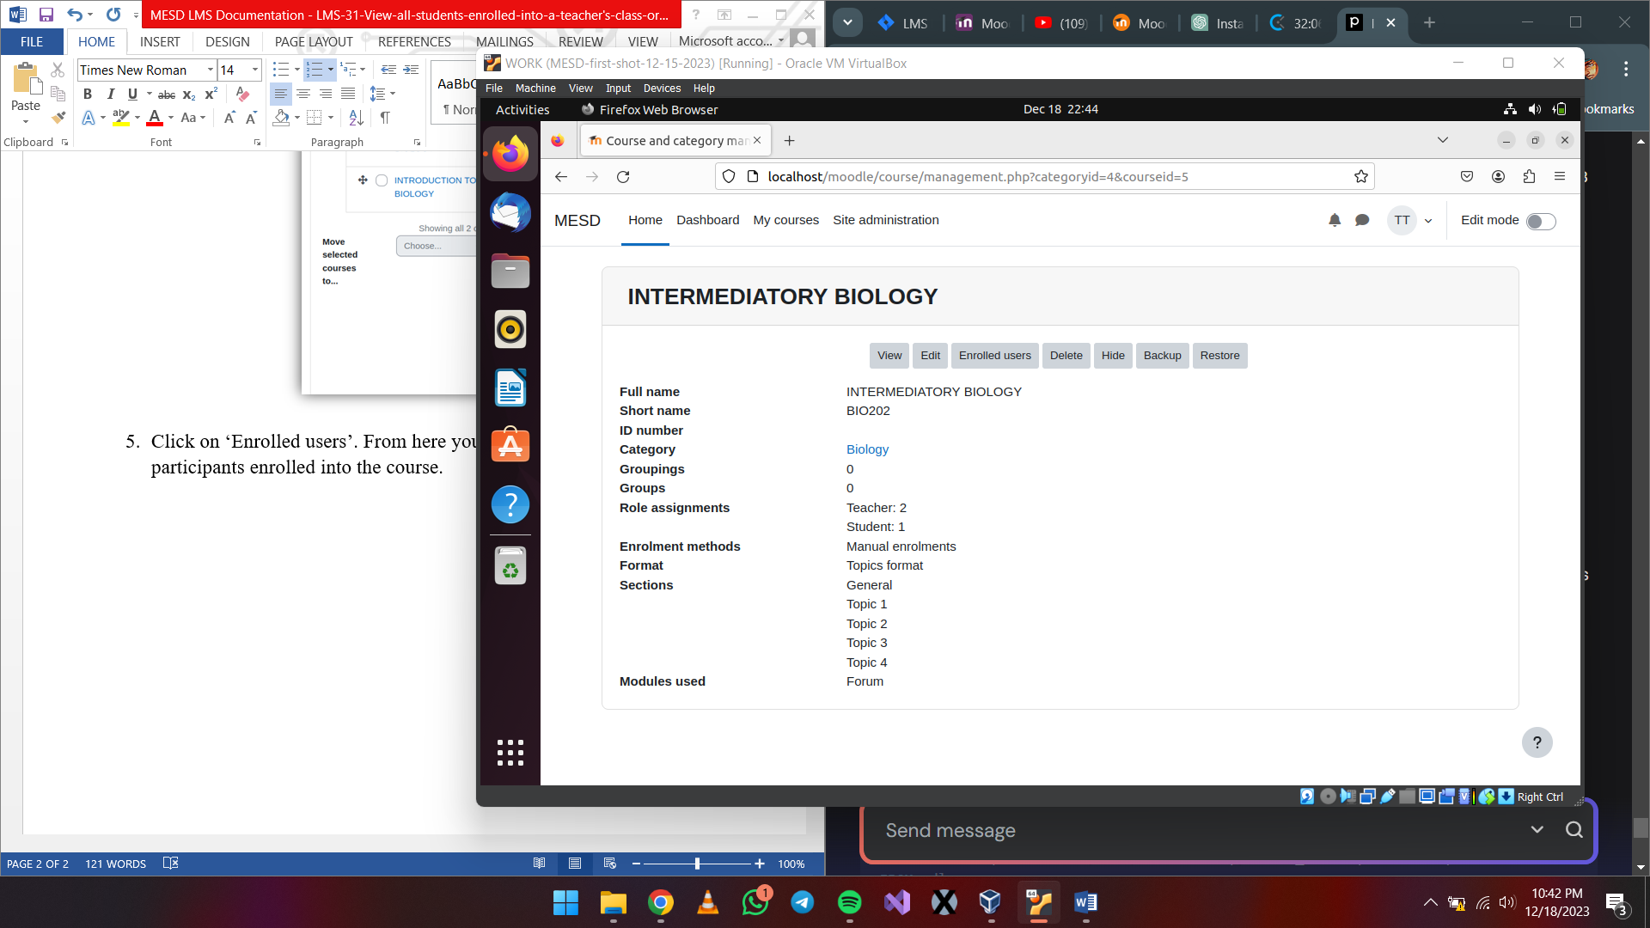

You can now view every participant under that course/subject.

